

**Course Title:** IT Project Management and Entrepreneurship

**Course code:** CSE495

**Section:** 2

**Semester:** Fall2023

**Implementation and Deployment Project of Intelligent System for**

**Enhancing Artistic Expression**

**Submitted To:**

Dipayan Bhadra

Adjunct Faculty,

CSE East West University

**Date of Submission: 26.12.2023**

**Submitted By:**

|  |  |
| --- | --- |
| **Name** | **ID** |
| Md. Habibuzzaman [Leader] | 2020-1-60-212 |
| Israfil Arman | 2020-1-60-086 |
| Shafia Hasnin | 2020-1-60-209 |
| Samiu Esika Upoma | 2020-1-60-082 |
| Zarin Tasnim Nuzhat | 2020-1-60-211 |

**Project Charter**

|  |  |
| --- | --- |
| Project Name: **Implementation and Deployment Project of Intelligent System for Enhancing Artistic**  **Expression** | |
| Project Owner: Zarin Tasnim Nuzhat | Decision Making Exec: Israfil Arman |
| Project Sponsor: Israfil Arman | Project Manager: Md. Habibuzzaman |
| Customer: Samiu Esika Upoma | Charter Date: 20.12.2023 |
| Expected Start Date: 01.01.2024 | Expected Completion Date: 07.11.2024 |
| **Project Description:**  In this interactive tool, users can draw various objects on a digital canvas, and our intelligent system will classify and measure the accuracy of their drawings.  The process begins with users expressing their creativity by sketching an object of their choice. Once the drawing is complete, our machine learning model steps in to classify and understand the drawn object. This is a challenging task, as drawings come in diverse styles, qualities, and complexities. Our model, trained on a wide range of examples, works to accurately recognize and understand the user's creation.  The next exciting step involves measuring the accuracy of the drawing. Our system evaluates the drawing against a set of criteria, providing users with specific feedback on the accuracy of their depiction. This feedback is not just about pointing out mistakes but aims to be constructive and actionable, guiding users on how to improve their drawing skills. | |
| **Project Mission:**  The mission of the Implementation and Deployment Project of Intelligent System for Enhancing Artistic Expression is to develop user-friendly software using advanced machine learning (like CNN) and a simple interface to help users improve their drawing skills. By fine-tuning accuracy, we aim to empower users to express themselves creatively, overcoming challenges like fine motor skill development. The project's purpose is to enhance drawing skills through personalized feedback, fostering a positive learning environment. Ultimately, our initiative seeks to positively influence users’ cognitive and emotional development, improving academic performance, and creating opportunities in fields that require precise drawing skills. | |

|  |
| --- |
| **Project Objectives:**   * Implement a user-friendly app for sketching objects. * Identify/detect the object drawn. * Measure the accuracy or correctness of the object drawn. |
| **Project Scope and Schedule:**     |  |  |  |  |  |  | | --- | --- | --- | --- | --- | --- | | **No.** | **KEY Activities and Milestones** | **Predecessor** | **Prerequisite** | **Duration of the**  **Activity /Date of the Milestone** | **Resource Allocation** | | 1 | Start | ----- |  |  |  | | 2 | Project Initiation | 1 | Define project goals and objectives | 1 week | 1 | | 3 | Stakeholder Identification | 2 | Identify key stakeholders and their roles | 1 week | 1,2 | | 4 | Requirement Gathering | 2 | Define user requirements and system specifications | 2 weeks | 1,2 | | 5 | System Design and Architecture | 3,4 | Complete requirement analysis and design system | 3 weeks | 1,2,6,7,8 | | 6 | Machine Learning Model Training | 5 | Collect and preprocess training data | 6 weeks | 5,7,8 | | 7 | Object Identification | 6 | Implement object detection algorithms | 4 weeks | 5 | | 8 | Accuracy Measurement Algorithm | 6 | Develop algorithms to measure drawing accuracy | 4 weeks | 1,4 | | 9 | User Interface Design | 5 | Design an intuitive and simple user interface | 3 weeks | 1,3 | | 10 | App Development | 6,7,8,9 | Implement user-friendly sketching app | 8 weeks | 1,4 | | 11 | ML Model Integration | 10 | Integrate machine learning model into the app | 4 weeks | 1,4,5 | | 12 | User Testing | 11 | Gather user feedback and make necessary adjustments | 2 weeks | 1,9,10 | | 13 | System Integration Testing | 11 | Ensure all components work together smoothly | 3 weeks | 1,9,10 | | 14 | Deployment | 12,13 | Release the app for public use | 2 weeks | 1,4 ,11 | | 15 | Monitoring and Maintenance | 14 |  | 4 weeks | 1,4 | | 16 | End | 15 |  |  |  | |
|  |

|  |  |  |  |  |  |  |  |  |
| --- | --- | --- | --- | --- | --- | --- | --- | --- |
| **Project Resources and Cost:** | | | | |  |  |  | |
|  | **COST TYPE** | **NO** | **VENDOR / LABOR NAMES** | **RATE/DAY** | **RESOURCE UNIT** | **DURATION**  **(DAYS)** | **TOTAL AMOUNT** |  |
| LABOR | 1 | Project Manager | 2500 | 100% | 165 | 4,12,500 |
|  | 2 | Project Analyst | 2000 | 100% | 22.5 | 45,000 |
|  | 3 | UX/UI Designer | 1200 | 100% | 15 | 18,000 |
|  | 4 | Developers | 1500 | 300% | 110 | 165,000 |
|  | 5 | Machine Learning Expert | 1500 | 200% | 70 | 105,000 |
|  | 6 | Database Engineer | 1500 | 100% | 15 | 22,500 |
| CONSULTANTS | 7 | Machine Learning Model Consultant | 2000 | 100% | 45 | 90,000 |
|  | 8 | Drawing Education Specialist | 2000 | 100% | 45 | 90,000 |
|  |  |  |  |  |  |  |
| TEST & QC | 9 | Test Engineer | 1500 | 200% | 12.5 | 18,750 |
|  | 10 | Quality Assurance Expert | 1500 | 100% | 12.5 | 18,750 |
|  |  |  |  |  |  |  |
| MATERIAL | 11 | Database Server |  |  |  | 45,000 |
|  |  | **TOTAL COSTS** |  |  |  | **1,030,500** |
| **Project Benefits:**   * Income from AppStore, Play Store and AdSense * Enhanced Drawing Accuracy * Cognitive and Artistic * Development Educational * Tool Positive Learning * Environment Efficient * Resource Utilization * Adaptable Learning Experience | | | | |  |  |  | |
| **Project Risks:**   * Machine Learning Model Accuracy * Bias in Machine Learning * Dataset Collection * Computational Resource Constraints * User Engagement * Privacy Concerns * Educational Effectiveness | | | | |  |  |  | |
|  | | | | |  |  |  | |
| **Project Stakeholders:**   * End Users (Kids and Children, Parents/Guardians) * Educational Institutions * Machine Learning Developers * User Interface Designers * Privacy and Legal Experts * Project Managers * Project Owner * Project Sponsor * Community Representatives * Environmental Experts * Educational Researchers | | | | | | | | |
| **Critical Success Factors (enablers):** Accurate Machine Learning Model, Engaging User Interface (UI/UX), Diverse Drawing Dataset, Adequate Computational Resources.  **Constraints:** Technological, Budget, Limited Computing Resources.  **Assumptions:** Technological stability, Educational Institution Collaboration. | | | | | | | | |
| **Other Related Projects/Initiatives:**   1. **Quick Draw**: Online drawing game by Google.   <https://indiaai.gov.in/article/exploring-quick-draw-an-online-game-by-google>   1. **Skribbl**: Online multiplayer drawing and guessing game. <https://skribbl.io/#:~:text=skribbl.io%20is%20a%20free,be%20crowned%20as%20the%20winner> 2. **Drawing Now**: Step by step online learning platform.   <https://www.drawingnow.com/> | | | | | | | | |

|  |  |  |  |
| --- | --- | --- | --- |
| Project Owner: | Zarin Tasnim Nuzhat | Project Manager: | Md. Habibuzzaman |
|  | **20-12-2023**  *Signature & Date* |  | **20-12-2023**  *Signature & Date* |

**Stakeholder, Risk Analysis and Management**

|  |  |  |  |  |  |  |  |
| --- | --- | --- | --- | --- | --- | --- | --- |
| **Stakeholders** | **Influence** | **Current**  **Support** | **Calculated Rating** | **Success Criteria** | **Action** | **Engagement Strategy** | **Lead** |
| End Users (Kids and  Children, Parents/Guardians) | 5 | 2 | 10 | Positive feedback from users, visible improvement in drawing skills, increased engagement | Implementing requested features, incorporating user suggestions, conducting user workshops. | Regular surveys, feedback sessions, and gamification  elements to make the tool enjoyable | User  Experience  (UX) team |
| Educational  Institutions | 4 | 3 | 12 | Improved academic performance, positive impact on fine motor  skills, integration into the curriculum | Customizing features for educational use, providing training materials, addressing institutional concerns | Collaborative workshops, pilot programs, and showcasing success stories. | Education liaison team |
| Machine Learning  Developers | 5 | 1 | 5 | High model  accuracy, adaptability to diverse drawing styles, scalability. | Continuous model refinement, addressing feedback,  fostering a culture of innovation. | Regular updates on model  performance, collaboration on model improvements, and recognition of contributions. | Machine  learning  research and development team |
| User Interface  Designers | 5 | 1 | 5 | Positive feedback on the interface, intuitive user  experience | Iterative design updates based on user feedback, ensuring accessibility standards. | User testing sessions, design workshops, and acknowledgment of design  excellence | UI/UX design team |
| Privacy and Legal  Experts | 4 | 2 | 8 | Compliance  with data protection laws, user trust in data security. | Periodic privacy audits, legal  compliance  checks, and quick response to legal inquiries. | Regular updates on privacy measures, transparency in data handling, and addressing  privacy concerns. | Legal and privacy compliance team |
| Project Managers | 5 | 1 | 5 | Timely project delivery,  adherence to budget, and | Risk assessment and management, | Regular project  updates, transparent communication, | Project management team, |
|  |  |  |  | successful feature implementation. | efficient project coordination, and proactive  issue resolution. | and addressing  concerns promptly. | communication specialists. |
| Community  Representatives | 4 | 2 | 8 | Positive community impact, active engagement. | Incorporating community suggestions, involving representatives in decisionmaking processes. | Community outreach programs, forums for open dialogue, and addressing community concerns. | Community engagement  specialists |
| Environmental  Experts | 4 | 2 | 8 | Sustainable software development practices, minimized environmental impact. | Conducting environmental impact assessments, implementing eco-friendly practices | Regular updates on eco-friendly features, collaboration on green initiatives. | Environmental impact assessment team |
| Educational  Researchers | 4 | 3 | 12 | Positive  findings in research on the tool's impact on learning and  cognitive development. | Providing necessary research materials,  participating  in research  conferences, and facilitating data access. | Collaborative research projects, sharing data for analysis, and acknowledging research contributions. | Research collaboration team |
| Project Owner | 5 | 1 | 5 | Successful project delivery, meeting  objectives within budget and timeline. | Providing necessary resources and support, resolving  high-level  issues, and  ensuring alignment with organizational goals | Regular project  updates, transparent communication,  and showcasing project milestones. | Project Owner,  Project  Managers |
| Project Sponsor | 5 | 1 | 5 | Positive impact on the  organization's goals, successful deployment, and recognition for supporting innovative  projects | Providing financial and strategic support, addressing high-level organizational concerns, and advocating for the project at higher levels. | Regular project briefings, demonstrating project value, and maintaining a strong partnership. | Project  Sponsor,  Project Owner |

|  |  |  |
| --- | --- | --- |
| Current Support | | |
| 1= Active supporter | | |
| 2= Moderately positive | | |
| 3=Neutral | | |
| 4= Moderately negative | | |
| 5=Negative | | |
|  | Power/Influence |  |
| 1= No power |
| 2= Some influence over project outcomes |
| 3= Moderate Influence |
| 4=Major influence on project |
| 5= Maximum influence |

|  |  |
| --- | --- |
| Stakeholder Rating | Thresholds |
| Major (must take action) | 13-25 |
| Minor (should take action) | 6-12 |
| Insignificant(observe) | 1-5 |

|  |  |  |  |  |
| --- | --- | --- | --- | --- |
| ***Risk Event Description***  ***And Impact*** | ***Probability***  ***H/M/L*** | ***Severity***  ***H/M/L*** | ***Mitigation Strategy*** | ***Who/When*** |
| 1. Machine Learning Model Accuracy:  The machine learning model may not accurately identify and classify drawings, leading to inaccurate feedback for users | H | H | Implement regular model updates based on user feedback, conduct extensive testing on diverse drawing styles during the development phase | Machine Learning  Developers, Continuous throughout the  project |
| 2. Bias in Machine Learning:    The machine learning model may exhibit bias, resulting in unfair or inaccurate evaluations, potentially affecting user  experience negatively | M | H | Implement fairness-aware machine learning techniques, conduct bias audits during model development, and ensure diverse and representative training  datasets | Machine Learning  Developers, Continuous throughout the project. |
| 3. Dataset Collection:  Inadequate or biased training data may lead to a model that doesn't generalize well to diverse user drawings | M | H | Use a diverse dataset representing various drawing styles, continuously update and expand the dataset based on user interactions, and conduct regular data quality assessments | Machine Learning  Developers, Continuous throughout the  project |
| 4. Computational Resource Constraints:    Insufficient computational resources may lead to delays in model training, deployment, or response times, impacting user experience | M | M | Optimize code and algorithms for efficiency, consider cloud-based solutions for scalability, and monitor resource usage during peak times. | DevOps and  Infrastructure  Team, Continuous throughout the project. |
| 5. User Engagement:  Users may not find the tool engaging, leading to low adoption rates and limited impact on drawing skill improvement | M | H | Conduct user feedback surveys, implement gamification elements, and regularly update the tool with new features to maintain user interest | User Experience  (UX) Team,  Continuous throughout the project. |
| 6. Privacy Concerns:    Users may have concerns about the privacy of their drawings and data, potentially leading to a loss of trust | M | H | Clearly communicate the data usage policy, implement robust data encryption, and regularly update users on privacy measures | Privacy and Legal  Experts,  Continuous throughout the  project |
| 7. Educational Effectiveness:    The tool may not effectively contribute to improving users' drawing skills or cognitive  development as intended | M | H | Collaborate with educational experts, conduct regular assessments on the tool's educational impact, and update features based on educational feedback | Education Liaison Team, Continuous throughout the  project |

|  |  |  |  |  |
| --- | --- | --- | --- | --- |
| **Severity (in Taka)** | **High** |  | 2,3,5,6,7 | 1 |
| **Medium** |  | 4 |  |
| **Low** |  |  |  |
|  |  | **Low** | **Medium** | **High** |
|  | **Probability** |  |

**Gantt Chart:**

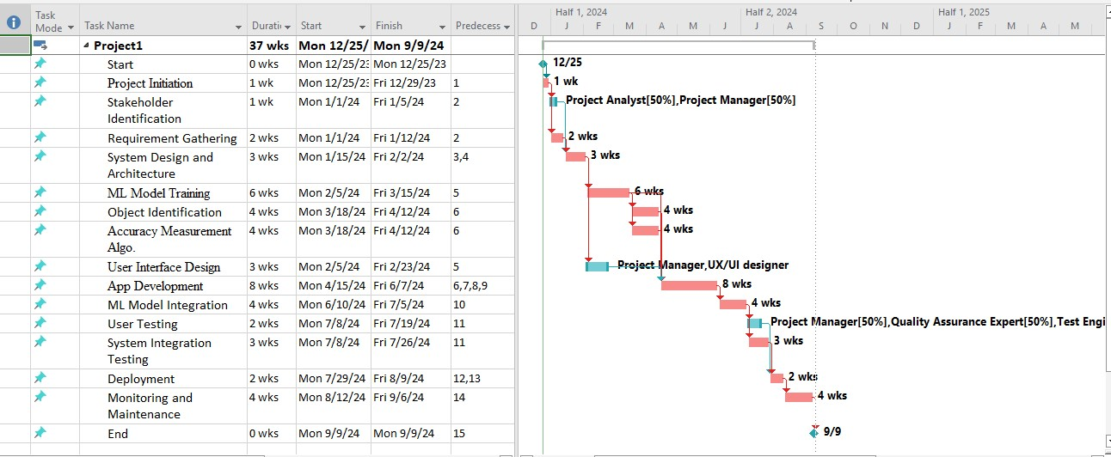

**Critical Tasks:**

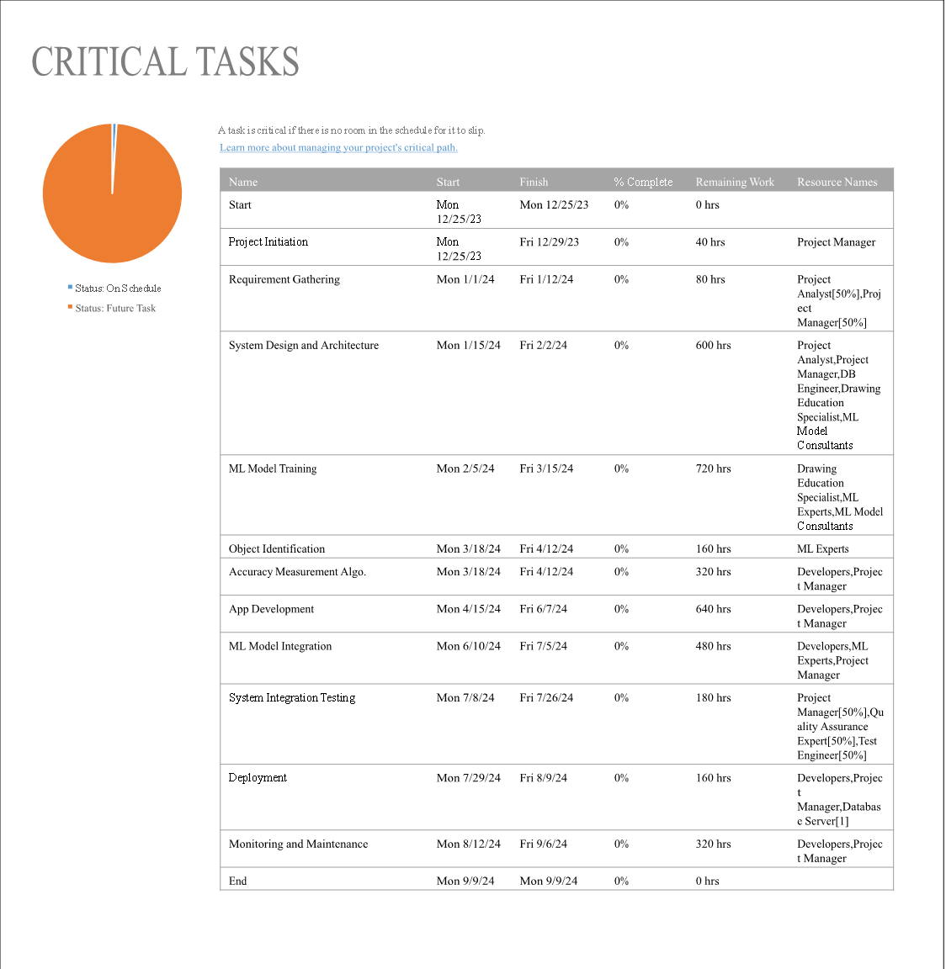

**Resource Allocation:**

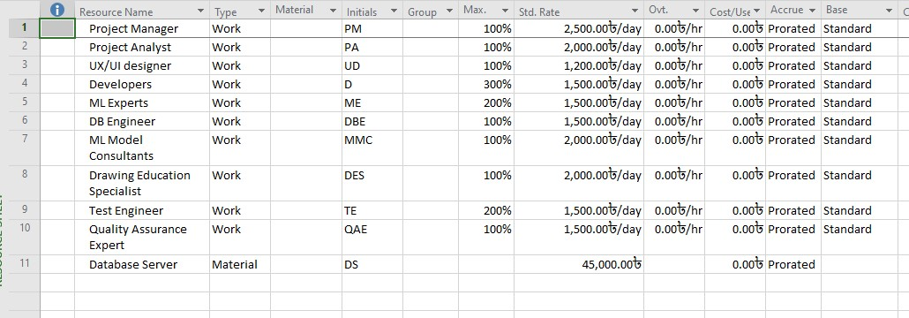

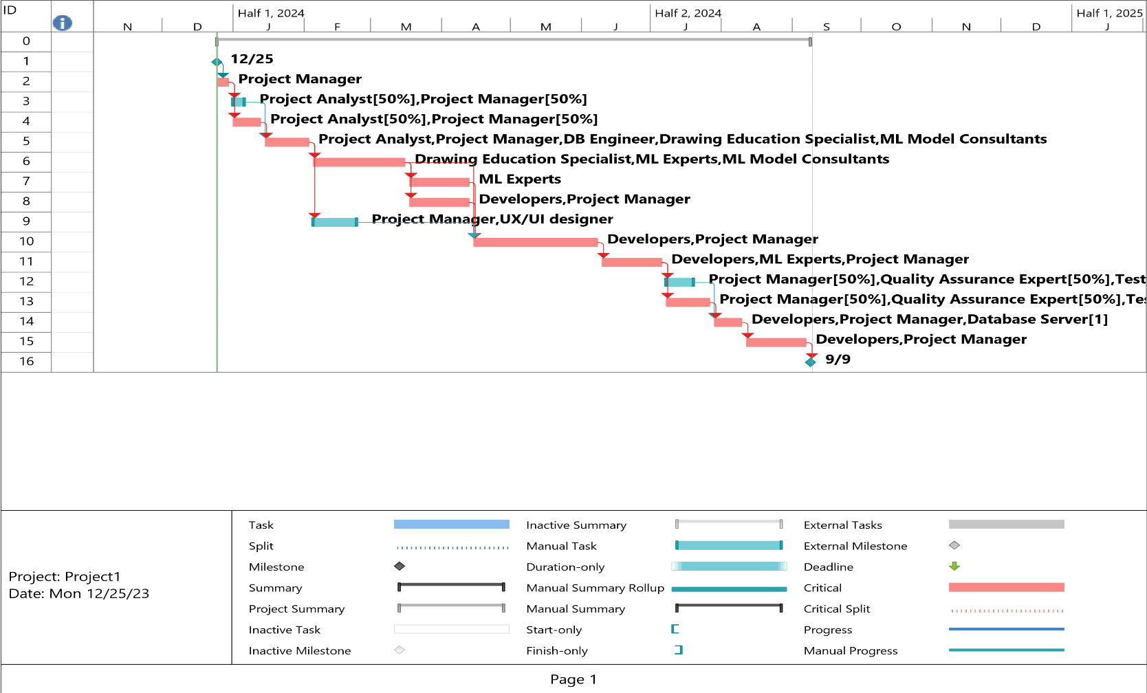

**Resource Overview:**

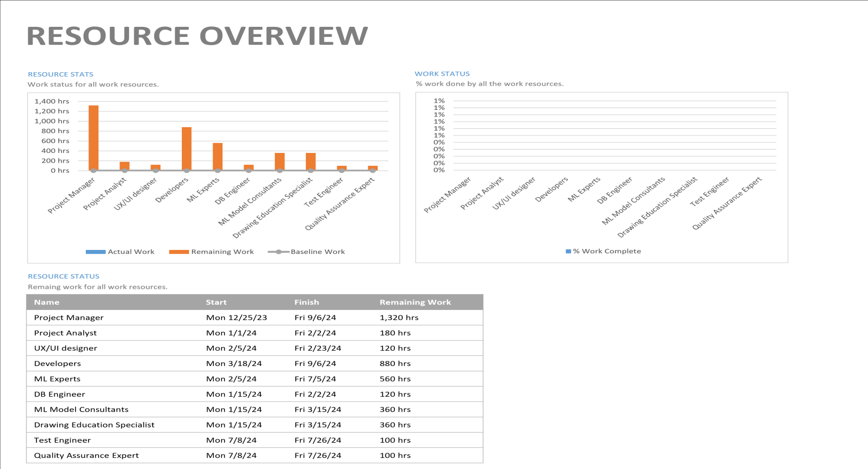

**Cost Overview:**

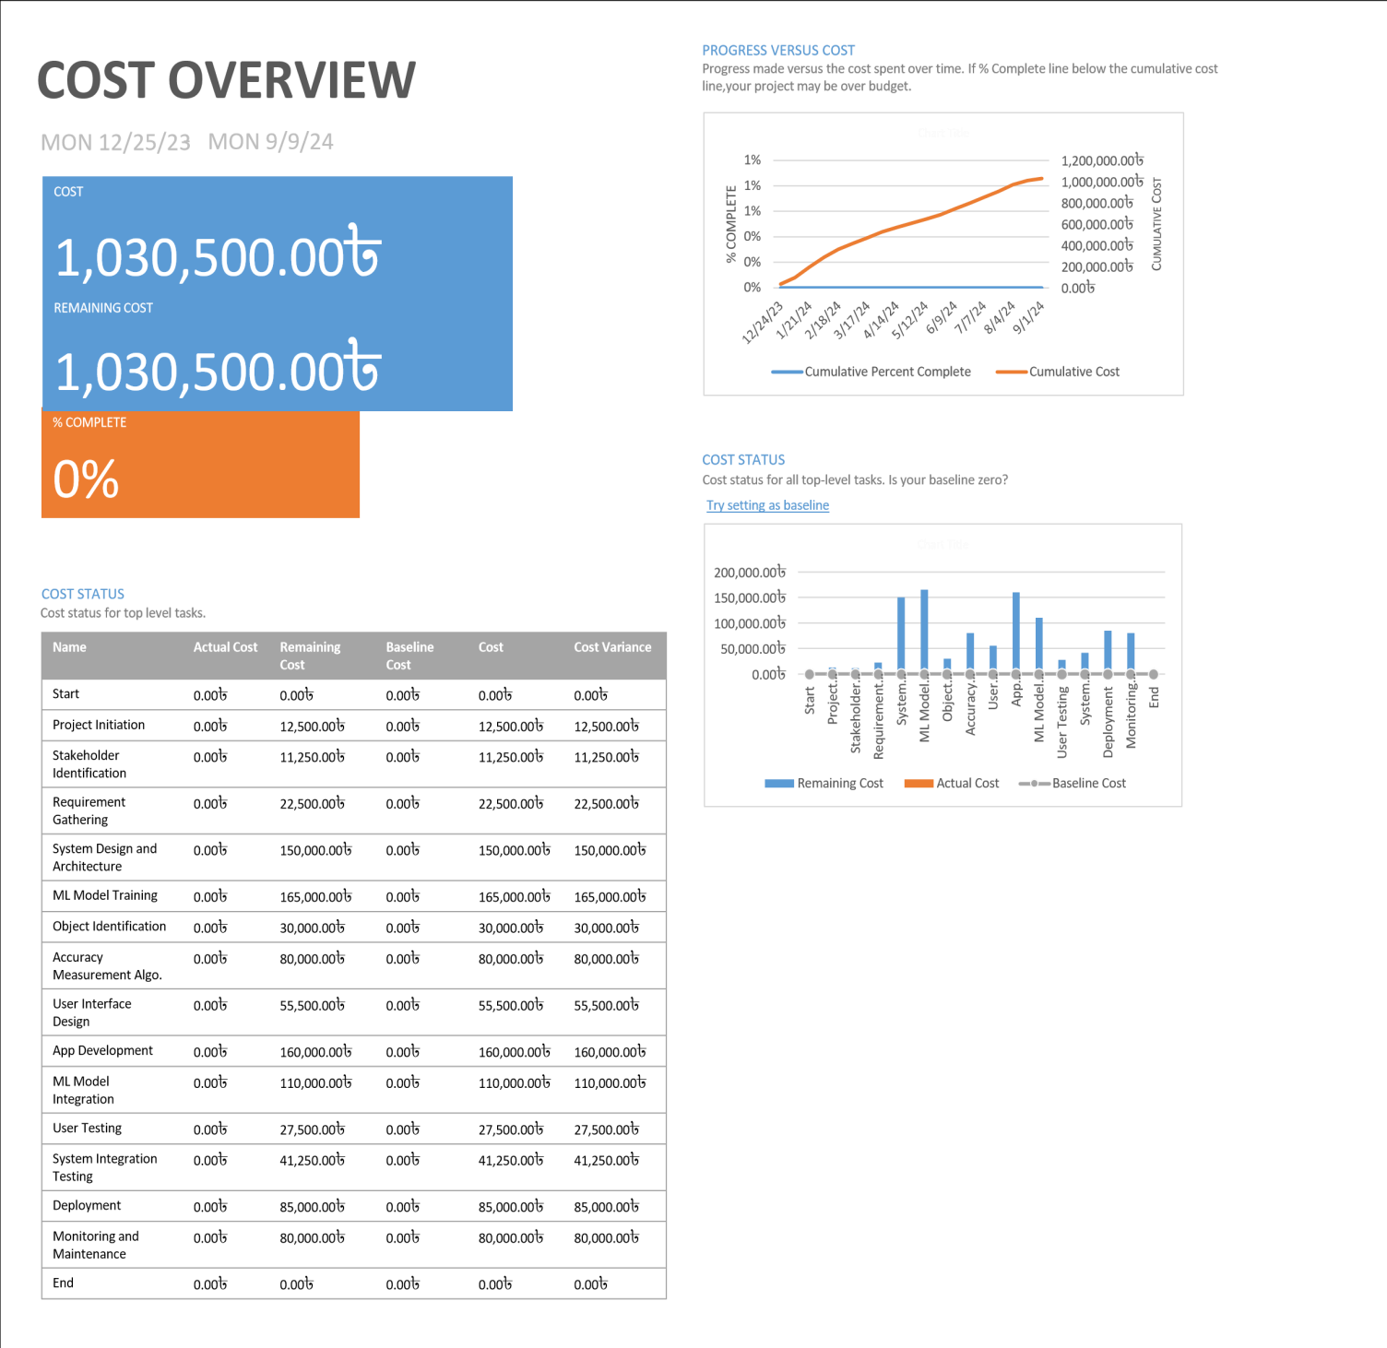

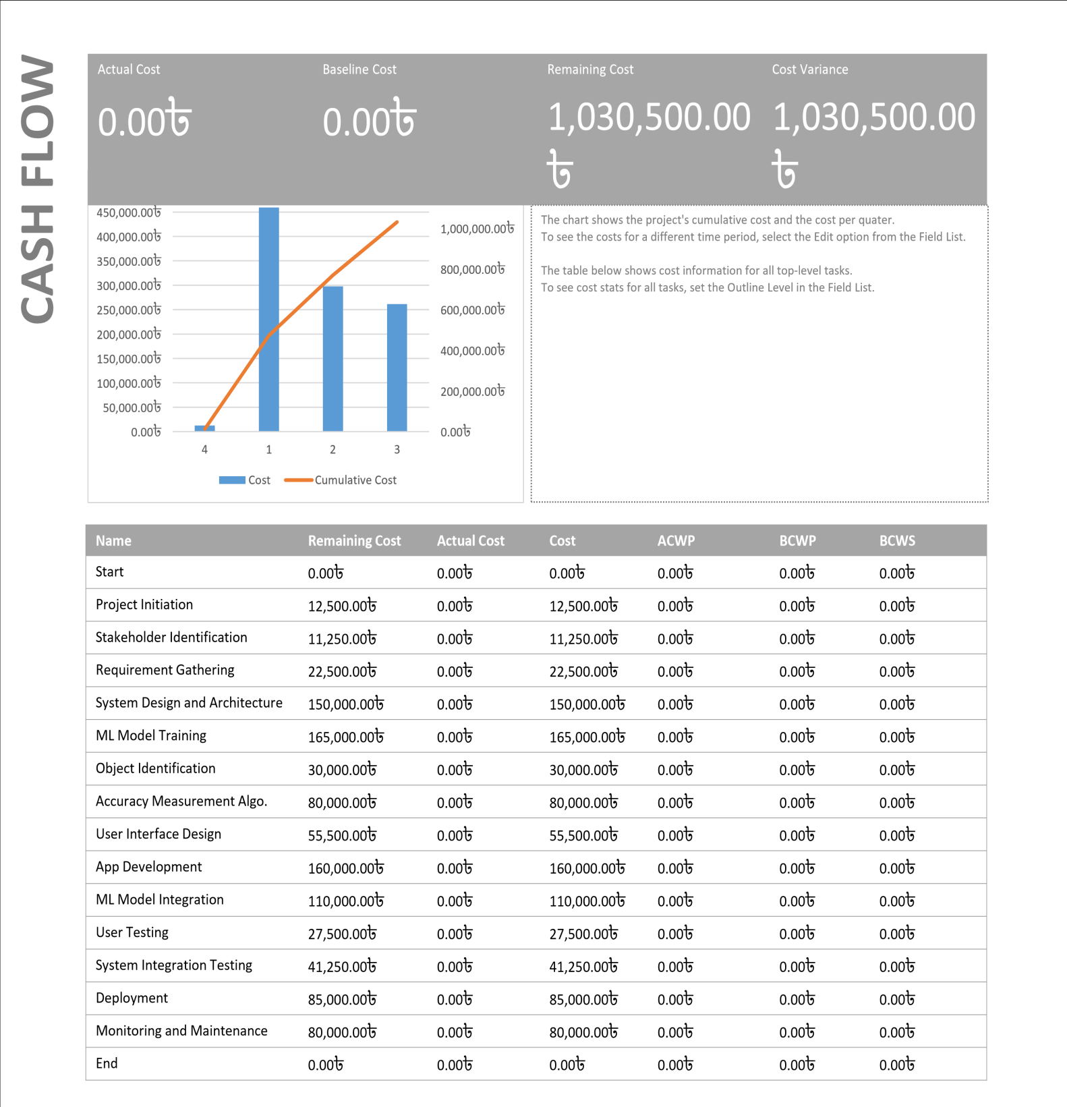

**Assumptions of Cost – Benefit Analysis:**

**A. Time:**

1. Project time is considered 1 year
2. Project Lifetime is considered 11 years, among 11 years, 1 year for project implementation and 10 years for project benefits

**B. Benefit:**

1. 75 Taka in considered for per download after 1 year.
2. 50% of the downloads will be increased every year.
3. 20 Taka per ad revenue is considered.
4. The annual rate of increment for the new AdSense considered 50%.
5. 500 takas will be saved per month per person for not wasting Paper while drawing practice. Can be used for drawing without any pencil or pen cost.
6. 1000 persons will be beneficiary in this process monthly.
7. Savings of $185 per ton of CO2 emission considered. 1000 users will have this impact on the environment. Each person will save 0.1kG of CO2,while using our app and going paperless.

**C. Cost:**

1. 3% of the investment cost per year is considered as maintenance cost (bug fixing, security update,algorithm optimization).

**Analysis:**

1. 12% discount rate is considered

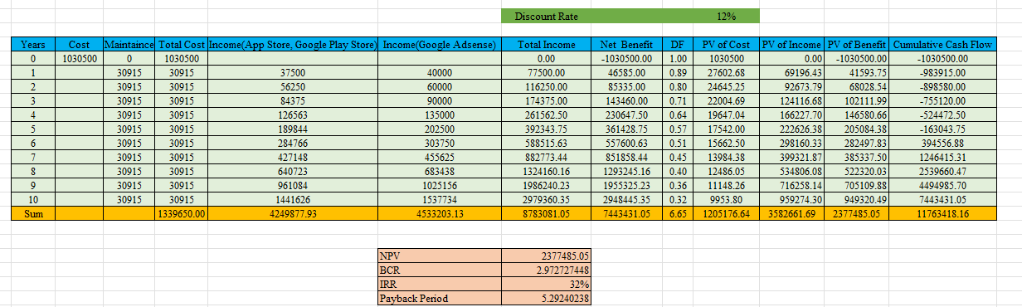

**NPV (Net Present Value):**

The project has a positive NPV of $2,377,485.05, indicating that the present value of expected cash flows exceeds the initial investment. This suggests the potential for profitability.

**BCR (Benefit-to-Cost Ratio):**

The Benefit-to-Cost Ratio is 2.97, signifying that for every dollar invested, there are approximately $2.97 in benefits. A BCR greater than 1 suggests a potentially worthwhile investment.

**IRR (Internal Rate of Return):**

IRR of 32% means the project is expected to give a return of 32% on the initial investment.

Higher IRR is generally better, indicating a more attractive investment.

**Payback Period:**

Payback Period of 5.29 years means it will take that time to recover the initial investment.

|  |  |  |  |  |  |  |  |  |  |  |
| --- | --- | --- | --- | --- | --- | --- | --- | --- | --- | --- |
| ID | Task Name | | Duration | Start | Finish | Predecessors | | Resource Names | Cost | |
| 0 | Project1 | | 37 wks | Mon  12/25/ | Mon  9/9/24 |  | |  | 1,030,500.00৳ | |
| 1 | Start | | 0 wks | Mon  12/25/2 | Mon  12/25/23 |  | |  | 0.00৳ | |
| 2 | Project Initiation | | 1 wk | Mon  12/25/2 | Fri  12/29/23 | 1 | | Project Manager | 12,500.00৳ | |
| 3 | Stakeholder Identification | | 1 wk | Mon  1/1/24 | Fri 1/5/24 | 2 | | Project Analyst[50%],Project Manager[50%] | 11,250.00৳ | |
| 4 | Requirement Gathering | | 2 wks | Mon  1/1/24 | Fri 1/12/24 | 2 | | Project Analyst[50%],Project Manager[50%] | 22,500.00৳ | |
| 5 | System Design and Architecture | | 3 wks | Mon  1/15/24 | Fri 2/2/24 | 3,4 | | Project Analyst,Project  Manager,DB  Engineer,Drawing Education  Specialist,ML | 150,000.00৳ | |
| 6 | ML Model  Training | | 6 wks | Mon  2/5/24 | Fri 3/15/24 | 5 | | Drawing Education  Specialist,ML Experts,ML | 165,000.00৳ | |
| 7 | Object  Identification | | 4 wks | Mon  3/18/24 | Fri 4/12/24 | 6 | | ML Experts | 30,000.00৳ | |
| 8 | Accuracy Measurement Algo. | | 4 wks | Mon  3/18/24 | Fri 4/12/24 | 6 | | Developers,Project Manager | 80,000.00৳ | |
| 9 | User Interface Design | | 3 wks | Mon  2/5/24 | Fri 2/23/24 | 5 | | Project Manager,UX/UI designer | 55,500.00৳ | |
| 10 | App Development | | 8 wks | Mon  4/15/24 | Fri 6/7/24 | 6,7,8,9 | | Developers,Project Manager | 160,000.00৳ | |
| 11 | ML Model  Integration | | 4 wks | Mon  6/10/24 | Fri 7/5/24 | 10 | | Developers,ML Experts,Project Manager | 110,000.00৳ | |
| 12 | User Testing | | 2 wks | Mon  7/8/24 | Fri 7/19/24 | 11 | | Project Manager[50%],Quality Assurance Ex | 27,500.00৳ | |
| 13 | System Integration  Testing | | 3 wks | Mon  7/8/24 | Fri 7/26/24 | 11 | | Project Manager[50%],Quality  Assurance Expert[50%],Test  Engineer[50%] | 41,250.00৳ | |
| 14 | Deployment | | 2 wks | Mon  7/29/24 | Fri 8/9/24 | 12,13 | | Developers,Project  Manager,Database Serv | e 85,000.00৳ | |
| 15 | Monitoring and Maintenance | | 4 wks | Mon  8/12/24 | Fri 9/6/24 | 14 | | Developers,Project Manager | 80,000.00৳ | |
| 16 | End | | 0 wks | Mon  9/9/24 | Mon  9/9/24 | 15 | |  | 0.00৳ | |
|  | |  | | | | | | | | |
| Project: Project1  Date: Mon 12/25/23 | |  | | | | | | | | |
| TaskInactive  SplitManual  MilestoneDuration-  SummaryManual  Project SummaryManual  Inactive TaskStart-  Inactive  onlyManual Progress | | | | | SummaryExternal Tasks TaskExternal Milestone onlyDeadline  Summary RollupCritical SummaryCritical Split onlyProgress  MilestoneFinish- | | |  |
|  |
|  |
|  |
|  |
|  | | Page 1 | | | | | | | | |

Discussions: